Trackpad CYTRG-114002-00 IQC and OQC Tester Setup and Operating Instructions

Instruction for Setting Up, Running and Updating Cypress Provided IQC Tester

**Paul Liu**

**Trackpad Senior Test Engineer, Cypress Trackpad Business Unit**

**David Solda**

**Marketing Director, Cypress Trackpad Business Unit**

**Revision 3**

**May 15th, 2013**

| Rev. | Orig. of  Change | Date of Change | Description of Change |
| --- | --- | --- | --- |
| 1 | JFLI | 05/02/2013 | Initial Release of CYTRG-114002-00 IQC Tester Instructions |
| 2 | DSO | 05/02/2013 | Correction of some text and information in the document |
| 3 | DSO | 05/15/2013 | Update document to include OQC testing process and criteria |

**LEGAL NOTICE**

The contents of this document are proprietary and confidential property of Cypress Semiconductor Corporation (Cypress). This document is provided subject to confidentiality obligations of the applicable agreement(s).

This document is intended for use of Cypress customers and collaborators only for the purpose for which this document is submitted by Cypress. No part of this document may be reproduced or made available to the public or to any third party in any form or means without the prior written permission of Cypress. This document is to be used by properly trained professional personnel. Any use of the contents in this document is limited strictly to the use(s) specifically authorized in the applicable agreement(s) under which the document is submitted. The user of this document may voluntarily provide suggestions, comments or other feedback to Cypress in respect of the contents of this document ("Feedback"). Such Feedback may be used in Cypress products and related specifications or other documentation. Accordingly, if the user of this document gives Cypress Feedback on the contents of this document, Cypress may freely use, disclose, reproduce, license, distribute and otherwise commercialize the Feedback in any Cypress product, technology, service, specification or other documentation.

Cypress operates a policy of ongoing development. Cypress reserves the right to make changes and improvements to any of the products and/or services described in this document or withdraw this document at any time without prior notice.

The contents of this document are provided "as is". Except as required by applicable law, no warranties of any kind, either express or implied, including, but not limited to, the implied warranties of merchantability and fitness for a particular purpose, are made in relation to the accuracy, reliability or contents of this document. Cypress SHALL NOT BE RESPONSIBLE IN ANY EVENT FOR ERRORS IN THIS DOCUMENT or for any loss of data or income or any special, incidental, consequential, indirect or direct damages howsoever caused, that might arise from the use of this document or any contents of this document.

This document and the product(s) it describes are protected by copyright according to the applicable laws.

Cypress Semiconductor is a registered trademark. Other product and company names mentioned herein may be trademarks or trade names of their respective owners.

Copyright of Cypress Semiconductor Corporation. All rights reserved.

**Table of Contents**

1. Introduction 4

2. Operating System Requirements 4

2.1 Hardware Requirements 4

2.2 Software Requirements 4

3. Cypress Trackpad IQC Tester Setup Instructions 5

3.1 Software Setup Instructions 5

4. IQC Test Procedure 10

5. IQC Update Procedure 13

6. IQC Testing Items 14

# Introduction

This document provides an introduction to the Cypress IQC tester and associated software that is required to correctly operate the IQC tester.

Cypress will provide IQC testing hardware to the end customer for incoming inspection of Cypress shipped devices to confirm that the devices are operating as intended.

All information within this document is disclosed under NDA.

# IQC Operating System Requirements

## Hardware Requirements

The following items are required in order to correctly run the Cypress IQC Tester:

1. IQC test fixture x1 (Cypress Provided)
2. Mini USB cable x1 (Cypress Provided)
3. Personal Computer x1 (to be provided by Customer)
4. Barcode Scanner x1 (QR code supported – to be provided by Customer)
5. Trackpad IQC test program CD x1 (Cypress Provided)

## Software Requirements

The following items are required in order to correctly operate the Cypress IQC Tester:

1. Operation System Requirements:
   1. Windows XP or Windows Vista or Windows 7
2. PSoC Programmer 3.15 or newer
3. Trackpad Module Tester
4. Cypress IQC / OQC Test Software

# Cypress Trackpad IQC Tester Setup Instructions

The Cypress Trackpad IQC tester consists of a test fixture and one USB cable connected to the fixture and the PC. No additional power supply is required for this tester.

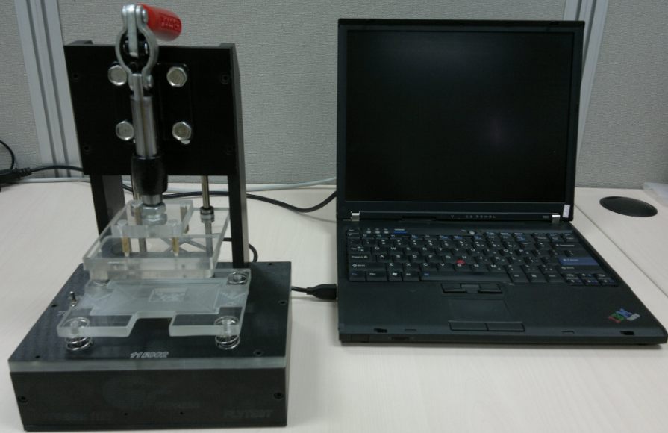

Picture of Cypress Trackpad IQC Tester

## Software Setup Instructions

The below instructions detail the steps for setting up the Cypress IQC Software Environment on the Target System.

1. Insert the Trackpad IQC test program CD into the CD-ROM.
2. Browse the CD and find the *“psocprogrammer_21.40.0.22”* folder.
3. Double click the cyautorun.exe to install the psoc_programmer.

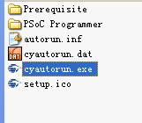

1. Click the “Install PSoC Programmer 3.15…” as shown in the below figure:

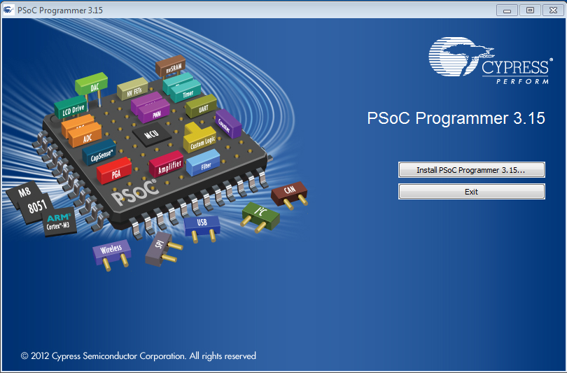

PSoC Programming Installation Screen

1. Click the “Next” button, and the installation will automatically start as shown below:

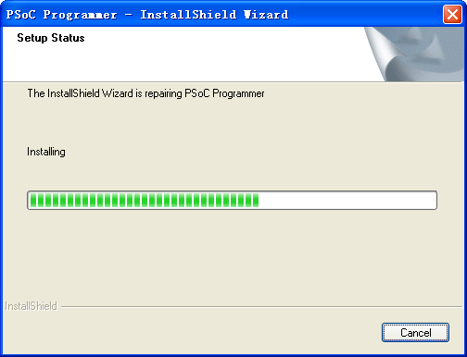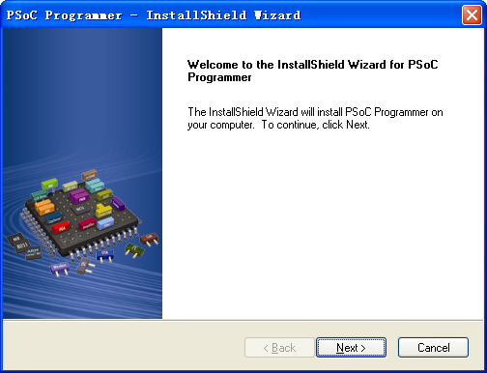

PSoC Programmer Installation GUI – Click “Next” and Application will install

1. Chose “Typical” installation type, and click “Next”

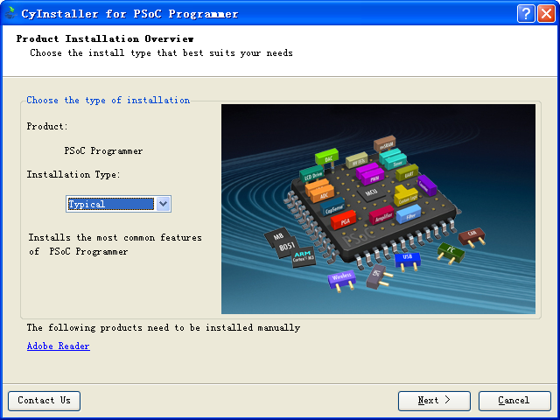

Installation Type Selection Screen

1. Chose “I accept the licenses agreement” and click “Next”

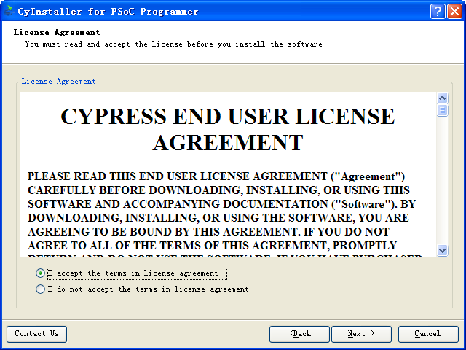

License and Agreement GUI Page

1. Wait for the installation to complete

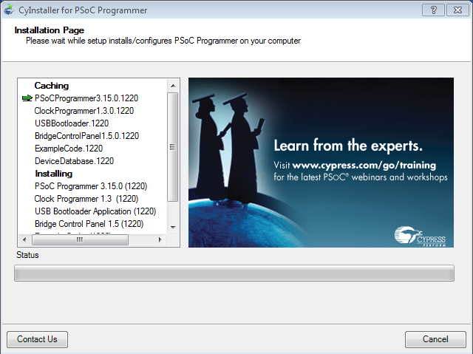

Screen Shot of Installation of PSoC Programmer

1. Click “Finish” once installation has completed. It is not necessary to view the release notes.

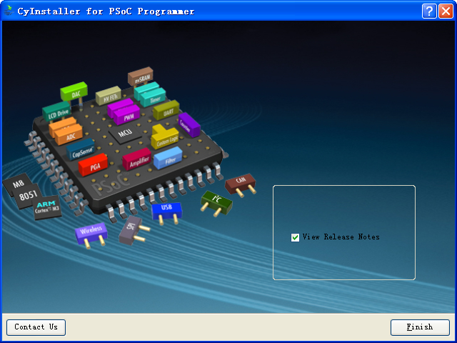

Screen Shot of Completed Installation – Click “Finish”

1. Browse the CD and located the “*Trackpad QC Tester*” folder.

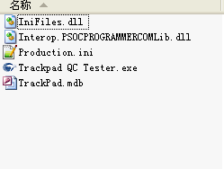

Contents of Trackpad QC Tester Folder

1. Copy this folder to any folder on the hard disk of the target PC system

# IQC Test Procedure

Follow the below section and instructions in order to correctly operate the IQC Tester after all installation steps in section 2.3 have completed.

1. Place a single Cypress Trackpad board on the plate board. (The round corner of Trackpad on near side and the non-component (sensor side) side facing up).

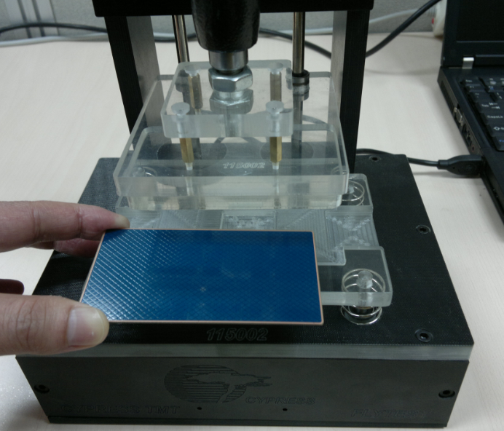

Orientation of the Cypress Trackpad placed in the IQC Plate Board

1. Push the hand lever down. The board will be connected to the pogo pins of the IQC Tester.

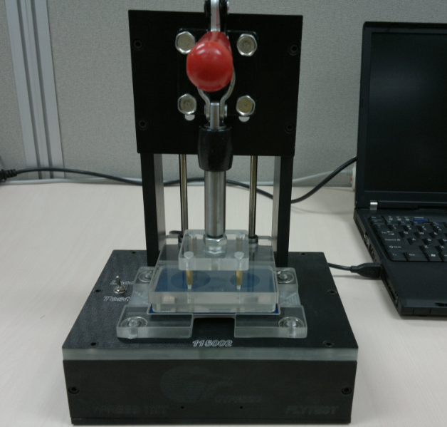

Orientation of the Hand Lever when the Board is connected to the IQC Tester

1. Connect the IQC Tester to the target PC computer through a mini-USB cable:

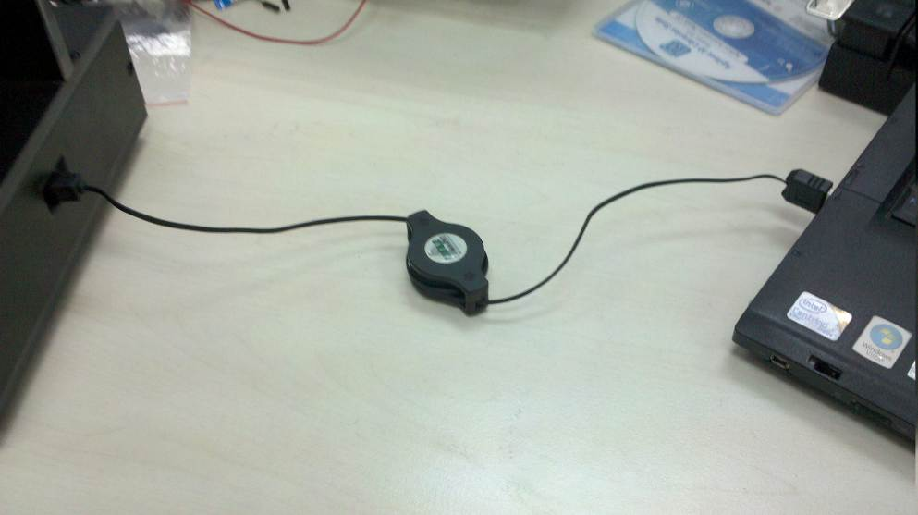

Connection of the IQC Tester to the Target PC System

1. Open the “Trackpad QC Tester.exe” file located in the “*114002 Trackpad QC Tester*” folder that was moved to the target PC systems Hard Drive.

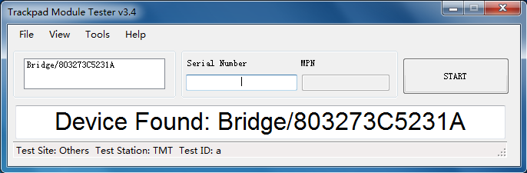

Screen Shot of the Trackpad QC Tester EXE Application

If the fixture is connected correctly to the PC, it will display in the device column on the top left side of the Trackpad QC Tester Application.

1. Single click the device of the device column

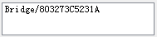

1. The device will open and display as shown below:

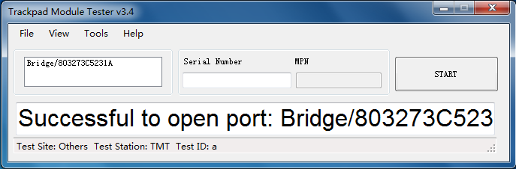

If the connection is not successfully able to open the port, try to unplug the cable and re-plug to PC again and repeat steps 4 through 6 of this section.

1. Click the Serial number column, and scan the serial number of Trackpad with barcode scanner, and click START button. Following this, the test will begin:

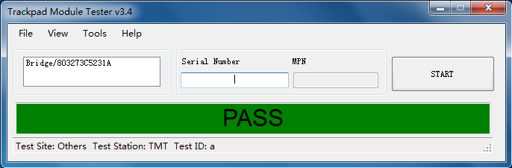

Screen Shot of completed Test

All test data is saved in “TrackPad.mdb” on the Target PCs Hard Drive in the folder that was copied to the Target PC.

# IQC Update Procedure

Once final firmware is released, the IQC tester should be updated to ensure that the relevant testing criteria and parameters are synchronized with the Firmware programmed into the final release Trackpad devices.

The update procedure is shown below:

1. Cypress will provide an updated file titled “Production.ini”
2. Located the folder “*Trackpad QC Tester*” that was copied to the test system in section 2.3.1, item 10.
3. Double click the “*Trackpad QC Tester*” folder
4. Locate the previous “Production.ini” file
5. Delete the current file on the Test System
6. Drag the newly provided “Production.ini” file into the “*Trackpad QC Tester*” Folder
7. The update is complete. The IQC tester can now run and is synchronized with the current production Firmware Version.

# IQC Testing Items

The following items are tested with the Cypress provided IQC tester to confirm product performance compliance:

1. The IQC measures and confirms the Silicon Internal Current Sourcing for compliance to the design specifications for each individual sensor:
   1. Measures and confirms the Minimum IDAC Value
   2. Measures and confirms the Maximum IDAC Value
2. The IQC measures and confirms the Trackpad system Maximum Noise is within design specifications.
3. The IQC measures and confirms the Trackpad Raw Count level based on the design specifications for each sensor:
   1. Confirms the Minimum Raw Count is within specification
   2. Confirms the Maximum Raw Count is within specification
   3. Confirms the Standard Deviation of the Raw Count is within specification
4. IQC Confirms the Trackpad Firmware Version programmed to the Trackpad
5. IQC Confirms the configured number of sensor lines for the X and Y dimensions are correct

# OQC Operating System Requirements

## Hardware Requirements

The following items are required in order to correctly run the OQC testing:

1. IQC test fixture x1 (Customer Provided – for holding the unit in place – this is optional, but recommended)
2. Mini USB cable x1 (Cypress Provided)
3. I2C-to-USB Bridge system (Cypress Provided)
4. FFC Cable for connection from adapter board to Trackpad Module
5. Trackpad Module to Host Adapter Board (Cypress Provided)
6. Personal Computer x1 (to be provided by Customer)
7. Barcode Scanner x1 (QR code supported – to be provided by Customer)
8. Trackpad OQC test program CD x1 (Cypress Provided)

## Software Requirements

The following items are required in order to correctly operate the Cypress OQC Tester:

1. Operation System Requirements:
   1. Windows XP or Windows Vista or Windows 7
2. PSoC Programmer 3.15 or newer
3. Cypress IQC / OQC Test Software

# Cypress Trackpad OQC Tester Setup Instructions

## Software Setup Instructions

Please follow the steps referenced in section 3.1. If the software is already installed on the system for IQC usage, it does not need to be reinstalled again.

# OQC Test Procedure

Follow the below section and instructions in order to correctly operate the OQC Tester after all installation steps in section 2.3 have completed.

1. Connect the USB cable from the Host Test PC to the I2C Bridge Board via the Mini-USB cable:

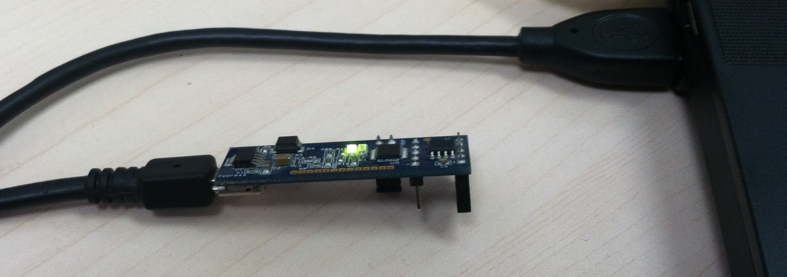

Connection of the Mini-USB cable from Host Test System to I2C Bridge Board

1. Connect the I2C Bridge and the Adapter board together as shown below:

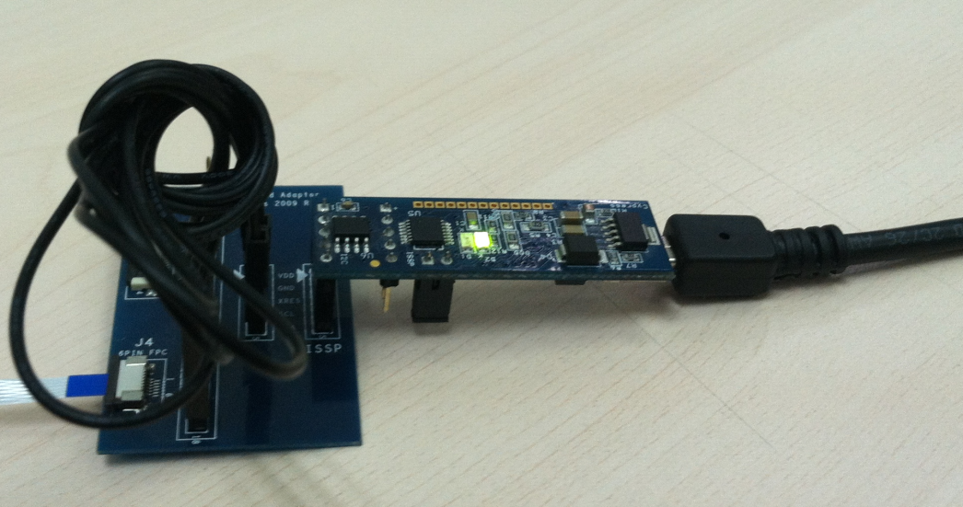

Connection of the Cypress Adapter Board and I2C Bridge Board

1. Connect the adapter board to the Trackpad Module via FFC cable:

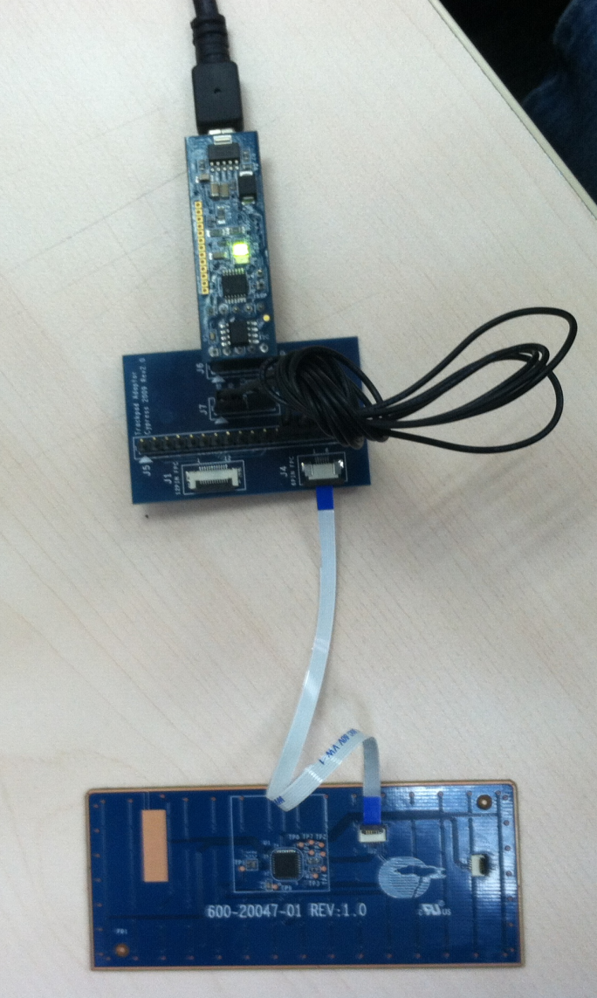

Connection of the Trackpad Module to the Adapter Board via FFC

NOTE: The picture above shows a connected system with the Trackpad only (no overlay). For the OQC testing in the ODM factory, the FFC cable should be connected to the Trackpad after the Trackpad is laminated to the plastic casing.

1. Open the “Trackpad QC Tester.exe” file located in the “*114002 Trackpad QC Tester*” folder that was moved to the target PC systems Hard Drive.



Screen Shot of the Trackpad QC Tester EXE Application

If the fixture is connected correctly to the PC, it will display in the device column on the top left side of the Trackpad QC Tester Application.

1. Single click the device of the device column



1. The device will open and display as shown below:



If the connection is not successfully able to open the port, try to unplug the Mini-USB cable and re-plug to PC again and repeat steps 4 through 6 of this section.

1. Set the tester software to OQC Mode with Finger Test. This can be done by Selecting the Mode file menu and selecting the “OQC Mode with Finger Test” option, as shown below:

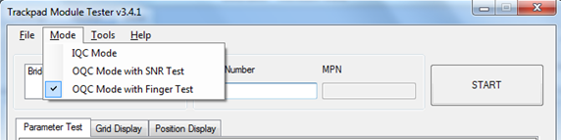

1. Click the Serial number column, and scan the serial number of Trackpad with barcode scanner, and click START button. Following this, the test will begin and the test Software will transfer to the “Position Display tab automatically.



Screen Shot of Test Beginning in the Position Display Tab

1. The first step of the OQC Functional test is to complete the left and right button testing first. Successful activation of the buttons will be confirmed by the OQC Test Software turning the Left and Right button status boxes green once detected. A screen shot of this area is shown below, both before successful activation and after.

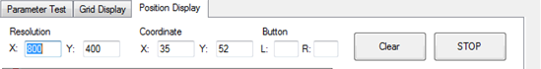

Location of Left and Right Button Status Indicators Prior to Activation

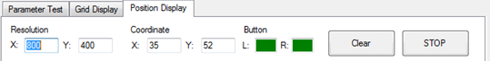

Display of the Left and Right Buttons After Both are Successfully Activated

SPECIAL NOTE: The button test much be completed before the finger movement test. The finger movement test will not be allowed to complete until after both Buttons have be verified. Failure to activate either of the buttons will result in a failure.

1. Following the button testing, begin the OQC Finger Movement Test by placing your finger on the RED circle shown in the display and then follow the pattern as described in the figure below. The test software will guide the operator on where to move the finger next by displaying a RED circle for where the operator is to move next.

NOTE that the red circle will disappear once the location has been contacted by the operators’ finger. After it disappears, move the finger to the next RED circle on the display with the finger while not removing the finger from the Trackpad surface.

During the test, the operator should note any gaps in the lines drawn in the display section. Gaps in the line may indicate desensitized areas that can be caused by poor lamination of the unit.

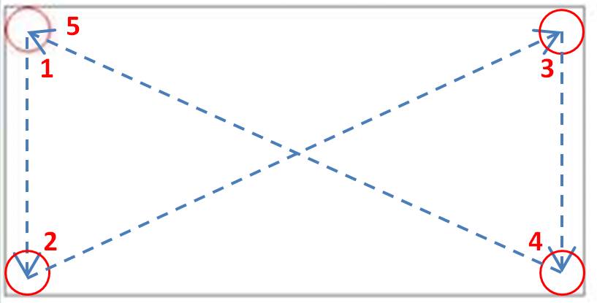

Figure of Patten Outlined in the Position Display Tab

1. Following successful completion of the button test and the finger test, the software will automatically redirect to the Parameter Test tab. The result of the test will be displayed on the bottom of the test software as shown below:

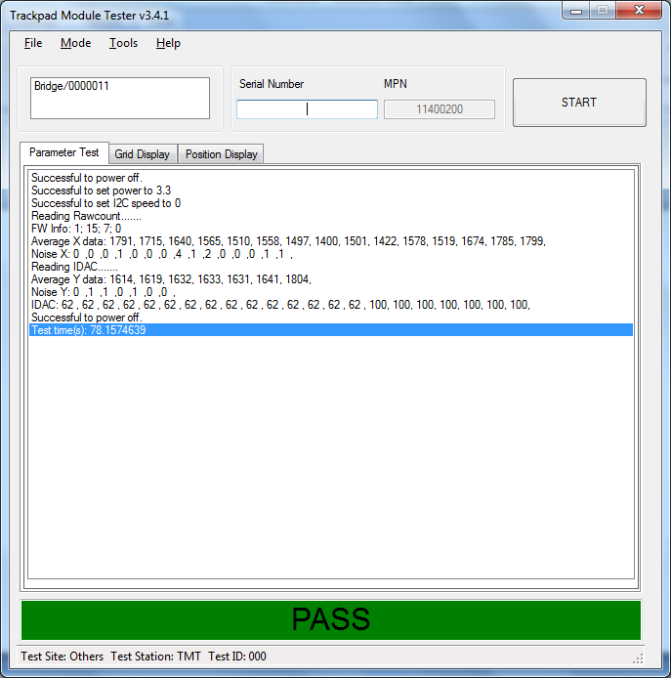

If the test fails, it will be displayed in Red along with the reason for failure.